7.5.4 Rotations of Conics Worksheet

- Identify and sketch the conic given by the equation

Since the equation contains an xy-term we know that it is a rotated conic.
We begin by attempting to find the angle of rotation.

Now we begin to find the value of x and y:

We can use these equations to convert the given equation
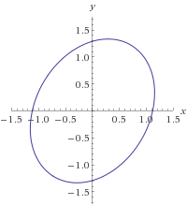
This is an ellipse with a center of . Note that , so the coordinates of the foci (with respect to the new axes) are .

- Identify and sketch the conic given by the equation

Since the equation contains an xy-term we know that it is a rotated conic.
We begin by attempting to find the angle of rotation.

Now we begin to find the value of x and y:

We can use these equations to convert the given equation
This is a hyperbola with a center of . Note that , so the coordinates of the foci (with respect to the new axes) are .
Also note that the equations for the asymptotes with respect to the new axes are:

- Show that the given equation is a parabola, then find its vertex, focus, and directrix in terms of the xy-axes and sketch a graph.

Since the equation contains an xy-term we know that it is a rotated conic.
We begin by attempting to find the angle of rotation using the previous theorem.

Since this equation is not easy to solve for we will instead use a triangle and some trig. identities:

We can use these equations to convert the given equation
This is a parabola with .
Therefore it has vertex , focus, and directrix with respect to the -axes.

To convert these to points/lines in the xy axes we will use the equations from the first theorem:

Vertex:
Focus:

Directrix: We have , so

- Identify and sketch the conic given by the equation

Since the equation contains an xy-term we know that it is a rotated conic.
We begin by attempting to find the angle of rotation using the previous theorem.

Since this equation is not easy to solve for we will instead use a triangle and some trig. identities. We should note that since we can always select as an acute angle this implies that . Therefore since this implies that .

-7
24
25

So now we calculate:

Notice that now we do not need to find the value of and can begin to find the value of x and y:

We can use these equations to convert the given equation
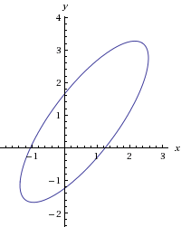
This is an ellipse with a center of . Note that , so the coordinates of the foci (with respect to the new axes) are .

